Explanation
Talha Yousaf
2025-CE-93
Experiment 1

SIGNALGENERATORANDOSCILLOSCOPE
- Use the signal generator and the oscilloscope to perform the following tasks.
- Build circuit‘ A’ shown below in Figure1.
- Set the signal generator to generate a sinusoidal signal with a frequency of100Hzandpeak-to peak voltage of 5V.
- Set up one probe across input signal, and an other across R1 andR2 alternatively.
- Measure and draw all the voltages and time related parameters on the graphs below.
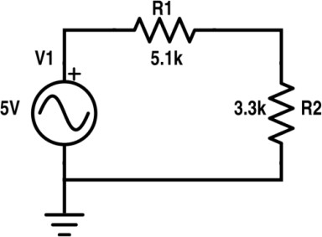

The circuit demonstrates how a series resistor network divides an input voltage signal, which is verified using an oscilloscope. The oscilloscope shows reduced amplitudes at different points while the waveform and frequency remain the same.
The circuit consists of the following components:
- Function Generator – produces an AC signal (sine, square, or triangle).
- R1 = 5.1 kΩ
- R2 = 3.3 kΩ
- Oscilloscope (Channels A, B, C, D) – used to observe voltages at different points.
- Ground – reference point of the circuit.
This circuit works on the voltage divider rule. Two resistors are connected in series and an input voltage is applied using the function generator. The oscilloscope is used to observe how the voltage changes across the circuit.
- Channel A displays the waveform of the input voltage from the function generator.
- Channel B shows the waveform after the voltage drop across R2 (3.3K)..
Channel B shows a sine waveform with reduced amplitude according to the voltage divider rule.
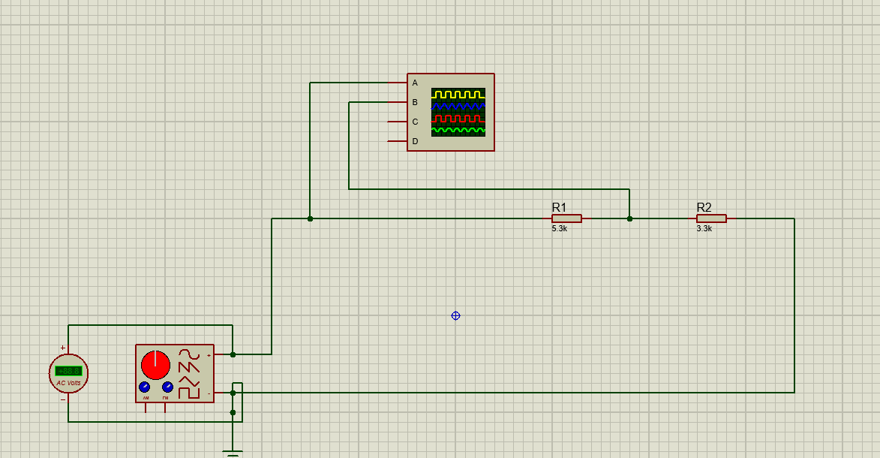

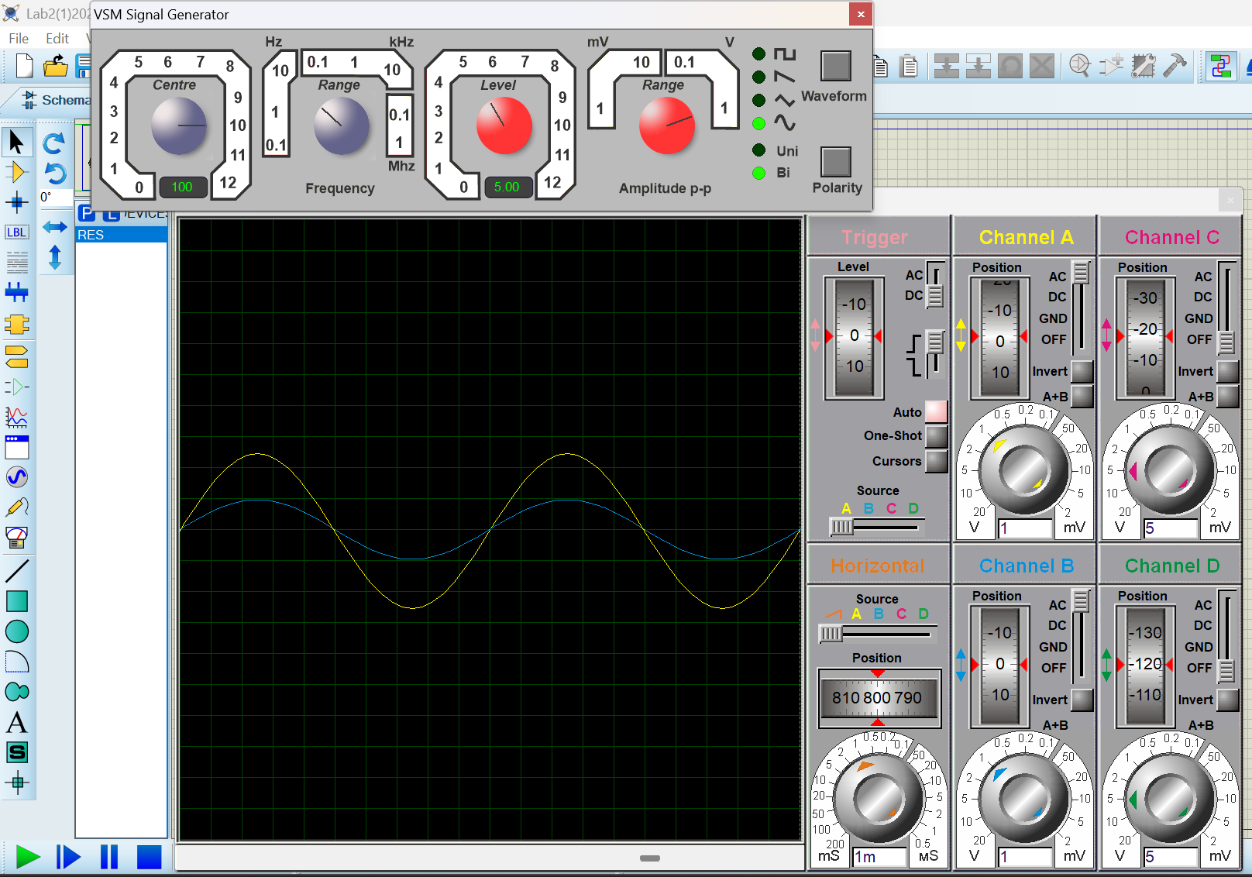

Experiment 2

Experiment#2
- Use the signal generator and the oscilloscope to perform the following tasks.
- Buildcircuit‘B’shownbelowinFigure7.
- Set the signal generator to generate a sinusoidal signal with a frequency of 200Hzandpeak-to peak voltage of 7V.
- Setup one probe across input signal, and another across R1, R2and R3 alternatively.
- Measure and draw all the voltages and time related parameters on the graphs below.
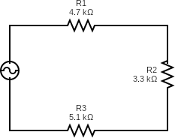
Explanation:
The simulation shows that when a 7 V peak-to-peak, 200 Hz input signal is applied to a series resistor network, the voltage divides across the resistors according to their resistance values. The oscilloscope displays the same waveform shape at different points but with decreasing amplitudes, confirming the voltage divider rule.
Given Values:
- Frequency = 200 Hz
- Input Voltage = 7 V (peak-to-peak)
- R1 = 4.7 kΩ
- R2 = 3.3 kΩ
- R3 = 5.6 kΩ
In this circuit, three resistors are connected in series, and a signal generator is used to apply the input voltage. An oscilloscope is used to observe how the voltage changes across the resistors.
- Channel A shows the original input waveform from the signal generator.
- Channel B shows the waveform after the voltage drop across R1 (4.7 kΩ).
- Channel C shows the waveform after the voltage drop across R1 and R2 (3.3 kΩ).
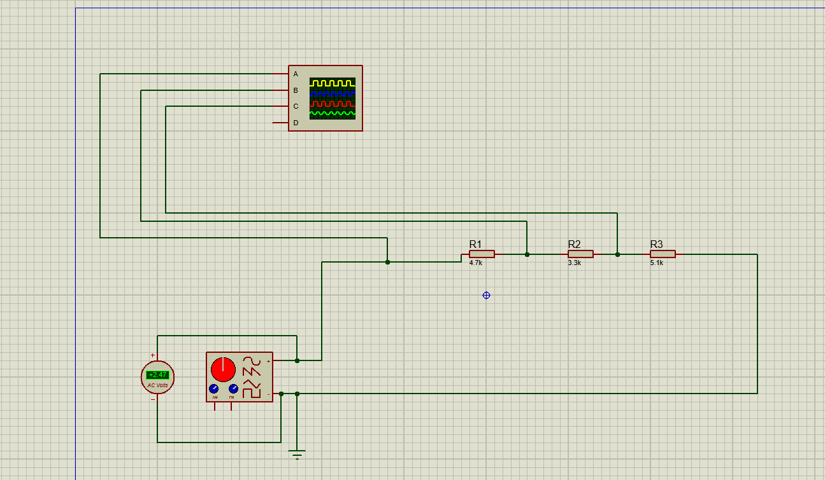
This demonstrates how voltage gradually decreases across each resistor in a series voltage divider circuit.
